**School of Computer Science**

**UNIVERSITY OF PETROLEUM AND ENERGY STUDIES**

**DEHRADUN, UTTARAKHAND**



System Monitoring And Configuration Management

**Lab File**

**(2024-2025)**

**for**

**6th Semester**

Submitted To: Submitted By:

Dr. Hitesh Kumar Sharma Abhishek Agarwal

B. Tech. CSE DevOps

[6h Semester]

Sap id- 500093614

Batch 2

R2142210028

**LAB EXERCISE 11**

Step 1: Create 2 AWS linux EC2 instances.

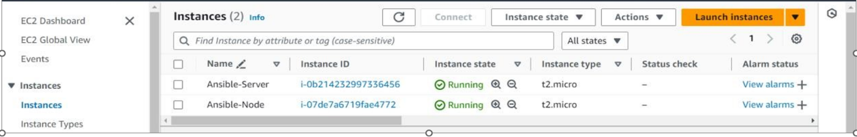

Step 2: Install ansible in Server machine.

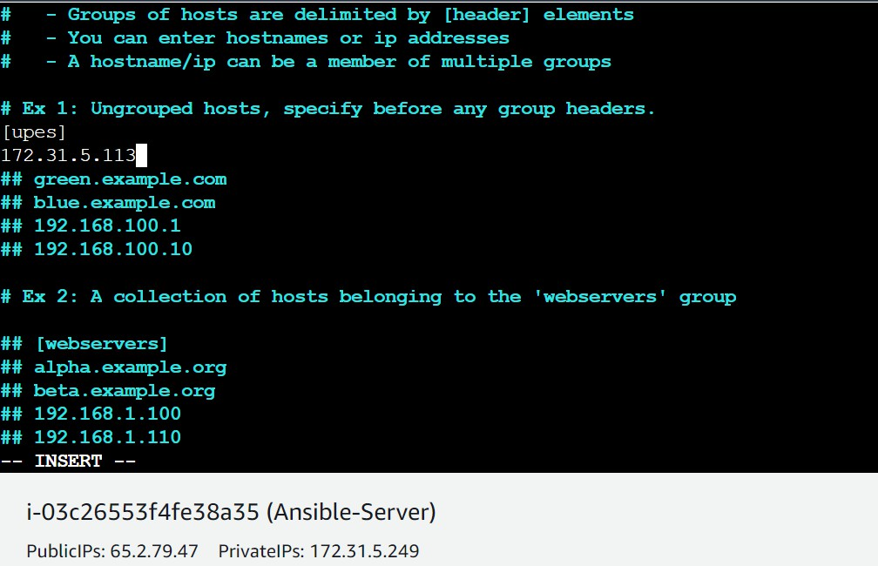Step 3: Add private ip of Node machine in list of known hosts in **/etc/ansible/hosts** file.

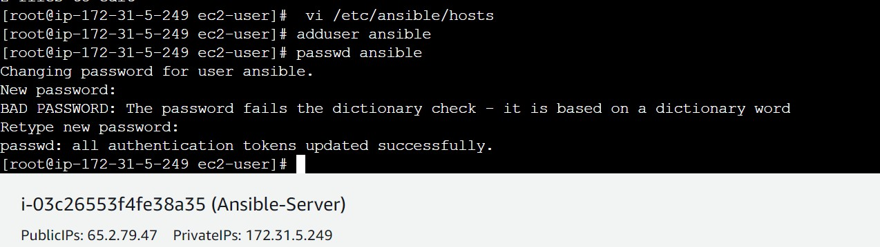Step 4: add user ansible in both server and node machine.

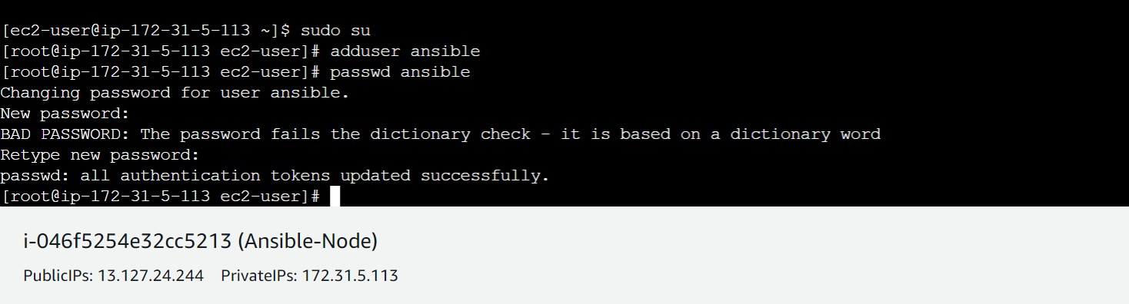

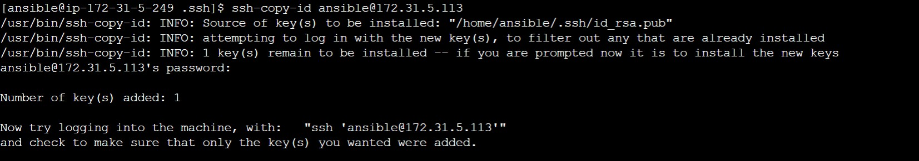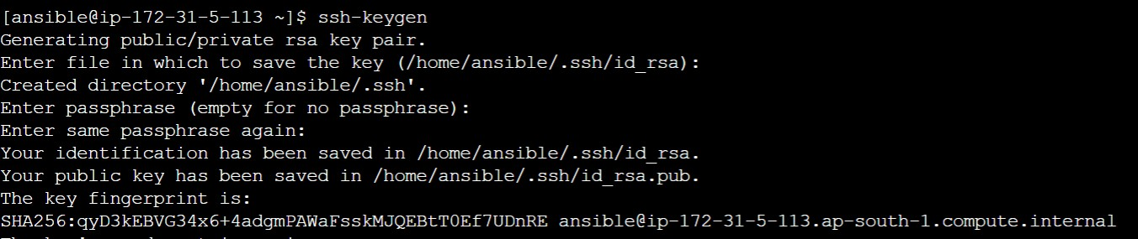Step 5: We have to generate a key pair and copy that into node machine.

Step 6: Key has been successfully added, now we can go into node machine through server only by ssh-ing into it’s private ip.

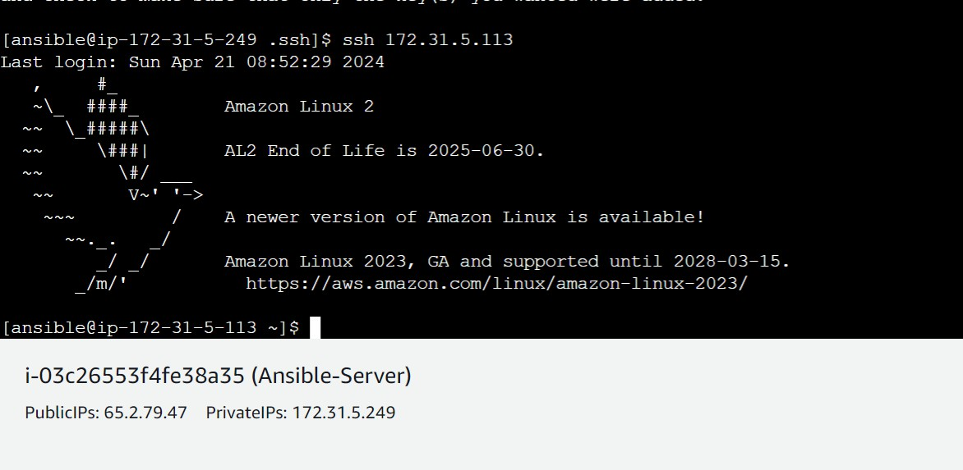

**LAB EXERCISE 12**

**Aim:** Ansible command and Playbooks.

Step1: Check lists of hosts.

Step2: install httpd.

Via Adhoc Commands:

Check in node.

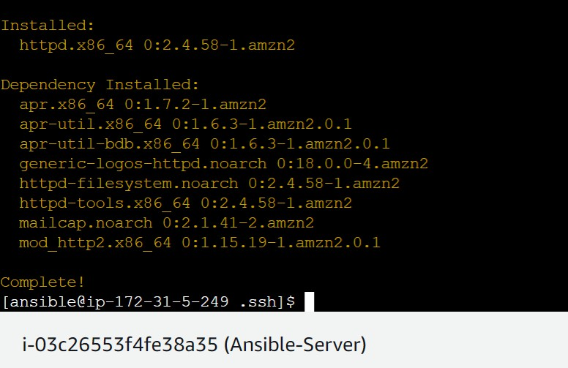Install on server using Adhoc commands.

Now check on node machine.



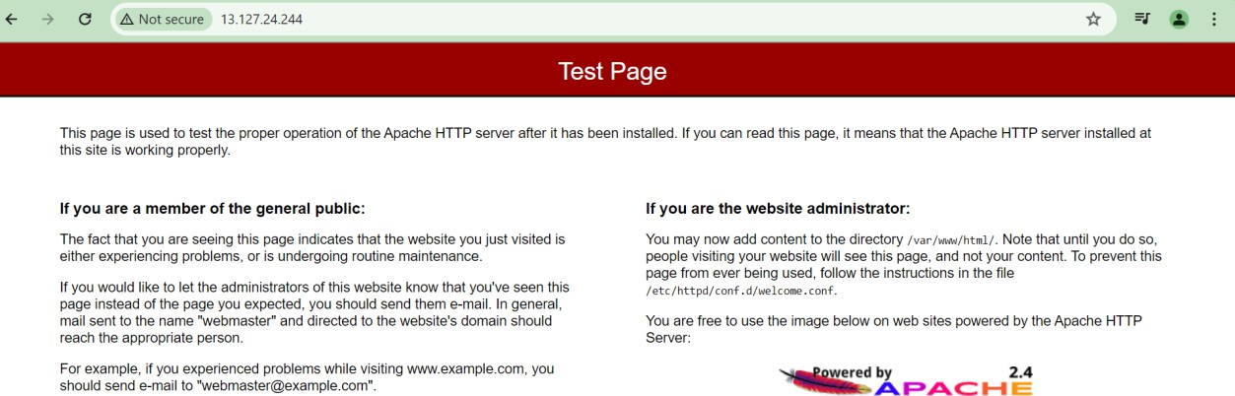Step3: Put public ip of node on browser and see apache web page.



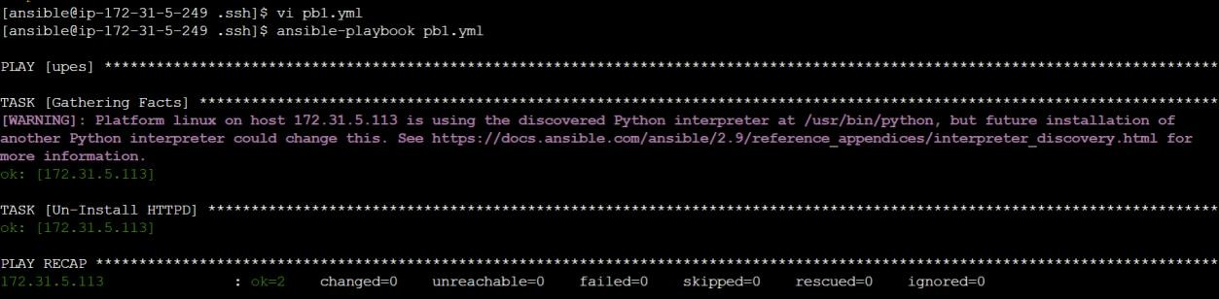Step4: Via Playbook.

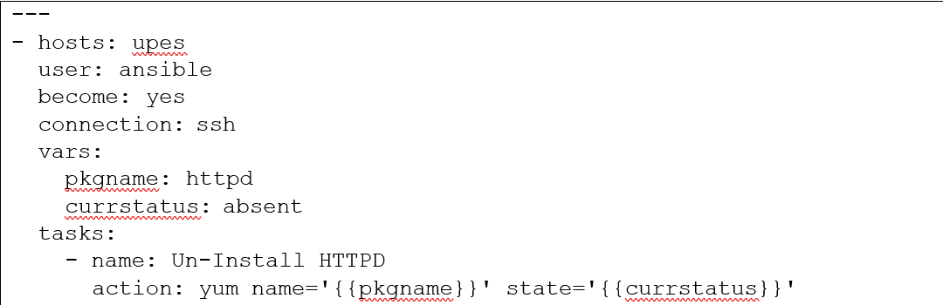Sample playbook